MODULE 4 – INTRODUCTION TO DBMS

LAB EXERCISES

18. SQL Cursors
Lab 1.
Write a PL / SQL block using explicit cursor to retrieve and display employee details.
Ans.
1. DELIMITER //

CREATE PROCEDURE show_employee_details()

BEGIN

DECLARE done int DEFAULT 0;
DECLARE eid int;
DECLARE ename varchar(255);
DECLARE dept int;

DECLARE emp_cursor CURSOR FOR SELECT emp_id, emp_name, dept_id FROM employees;

DECLARE CONTINUE HANDLER for NOT FOUND SET done = 1;

OPEN emp_cursor;

read_loop: LOOP

FETCH emp_cursor INTO eid, ename, dept;

IF done = 1 THEN
LEAVE read_loop;
END IF;

SELECT eid AS ID, ename AS Name, dept AS Department;

END LOOP;

CLOSE emp_cursor;

END //

DELIMITER ;

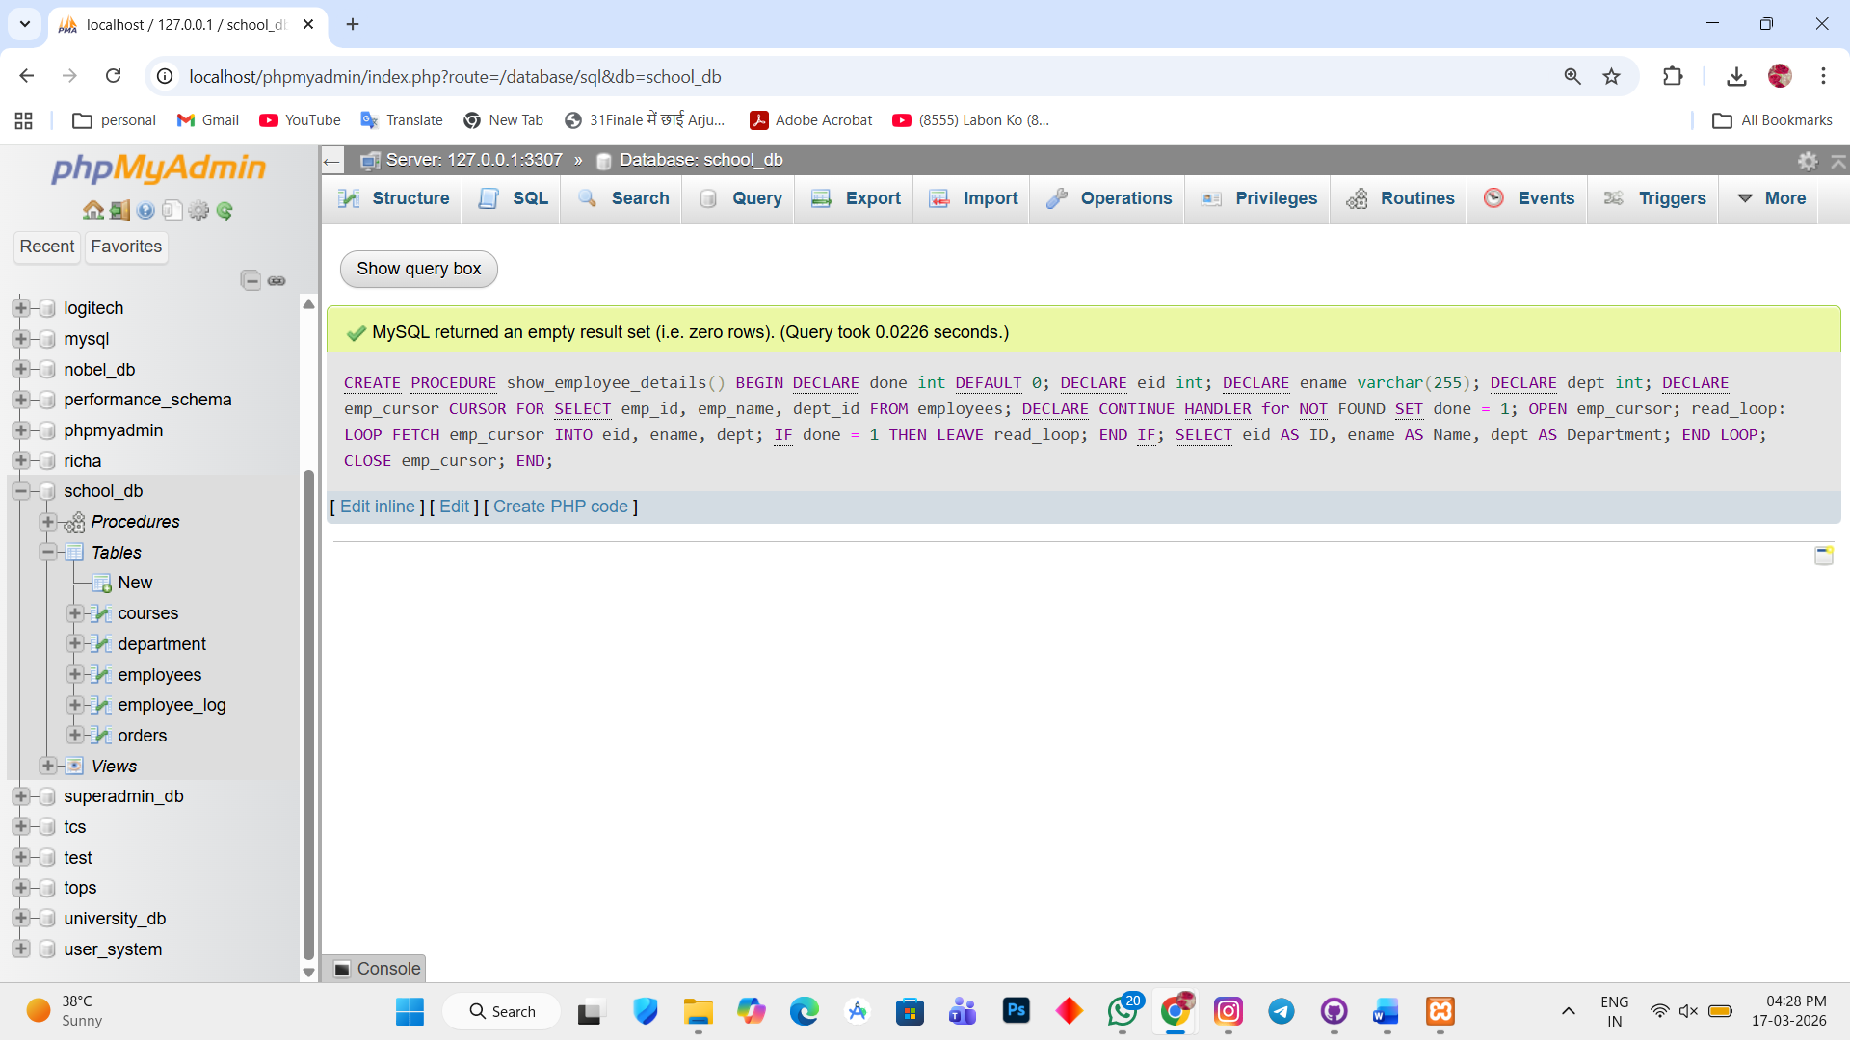

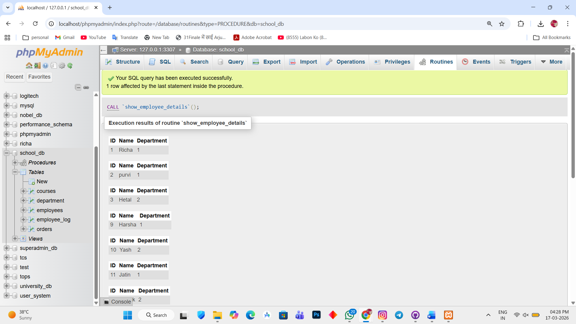

Lab 2.
Create a cursor to retrieve all courses and display them one by one.
Ans.
1. DELIMITER //

CREATE PROCEDURE show_courses()

BEGIN

DECLARE done int DEFAULT 0;
DECLARE cname varchar(255);
DECLARE duration varchar(255);

DECLARE course_cursor CURSOR FOR SELECT course_name, course_duration FROM courses;

DECLARE CONTINUE HANDLER FOR NOT FOUND SET done = 1;

OPEN course_cursor;

course_loop: LOOP

FETCH course_cursor INTO cname, duration;

IF done = 1 THEN
LEAVE course_loop;
END IF;

SELECT cname AS Course_name, duration AS Duration;

END LOOP;

CLOSE course_cursor;

END //

DELIMITER ;

